NAME OF STUDENT: ................................................................................................... STUDENT NUMBER: ...........................................

SUBJECT:  APPLICATIONS DEVELOPMENT FUNDAMENTALS II  (ADF 260S / 261S / 262S) | DATE:  30th Sept 2020 | TIME:  90 Mins.  TOTAL MARKS:  80



DEPARTMENT OF INFORMATION TECHNOLOGY
FACULTY OF INFORMATICS AND DESIGN

COURSE(S): DIPICTA: DIPLOMA IN INFORMATION AND COMMUNICATION TECHNOLOGY:
APPLICATIONS DEVELOPMENT

EXAMINER: mr A MUKHERJEE
INTERNAL MODERATOR: ms Sheetal Tom

SPECIAL INSTRUCTIONS
- Answer all the questions.
- Not an open book exam.
- PLEASE WRITE YOUR SURNAME INITIAL AND STUDENT NUMBER IN THE LAST PAGE (Labelled Answer Script). Scan It and Upload it in BB.
- YOU MAY BE ASKED TO CLARIFY YOUR ANSWERS VIA BB COLLABORATE / ZOOM

REQUIREMENTS
- None

QUESTION 1 [20]
0
3
1
8
2
12
3
6
4
2
5
7
D
C
E
B
F
G
A

8

Fig 1.
Check the directed graph given in Fig 1. A is the source vertex. Using Dijkstra’s Algorithm complete the table in the answer script.
QUESTION 2 [20]

Given the following Directed Graph in Fig 2.
 | 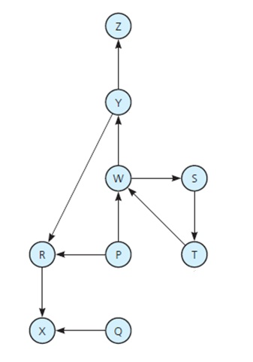
 | 2.1. | Complete the Adjacency Matrix in the Answer Page. | (10)
 | 2.2. | Complete the Adjacency List in the Answer Page. | (10)
QUESTION 3 [10X2 = 20]

3.1. The DFS algorithm has been implemented using the queue data structure. One possible order of visiting the nodes of the following graph is (Imagine the traversal starts with M)
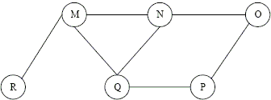 | (A) MNOPQR  (B) NQMPOR  (C) QMNPRO  (D) NONE OF THE ABOVE

3.2 Which one of the following option will be the result of the BFS tree of the given graph:

- ABDHLIEJMCFGK
- ABDHILEJCMFGK
- ABCDEFGHIJKLM
- NONE OF THE ABOVE

QUESTION 4 [20]
4.1 Check the graph given in the figure below:  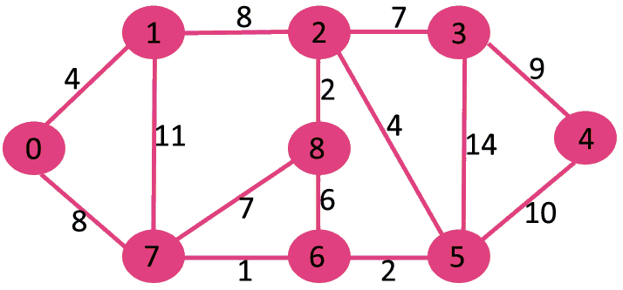  Draw the MST(Minimum Spanning Tree) using PRIM’s Alogorithm and calculate the total weight of the MST.  4.2. Check the graph given in the figure below:  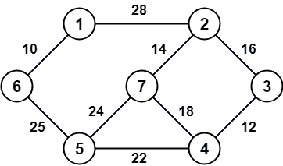  Draw the MST(Minimum Spanning Tree) using KRUSKAL’s Alogorithm and calculate the total weight of the MST. |  |  | (8+2)  (8+2)
******************************** END OF TEST********************************

ANSWER PAGE
Surname, initial (In Block Letters): ___________________________________________

Student Number:____________________________________________

(Please remove this page from the question paper and put it inside your answer book.
ALL THE STEPS FOR THE ANSWERS MUST BE THERE IN THE ANSWER BOOK)

ANSWER 1:

A | B | C | D | E | F | G
0
ANSWER 2:
2.1.
 | P | Q | R | S | T | W | X | Y | Z
P
Q
R
S
T
W
X
Y
Z

2.2.
P
Q
R
S
T
W
X
Y
Z

ANSWER 3 (Steps and the BFS and DFS tree must be drawn in the answer book):
3.1.

3.2.

ANSWER 4:
4.1. Graph

Total Weight

4.2. Graph

Total Weight

THE END

